Homework 2

1. a. VALID

AaBb (S = AaBb)

baBb (A = b)

baab (B = a)

b. INVALID

c. INVALID

d. VALID

AaBb (S = AaBb)

AbaBb (A = Ab)

bbaBb (A = b)

bbaab (B = a)

|  |  |
| --- | --- |
| Tokens | Lexemes |
| Identifiers | A, B, C |
| Assignment Operator | = |
| Arithmetic Operators | +, * |
| Parentheses | (, ) |

3. <assign> <id> = <expr>

<id> = <expr>

B = <expr>

B = <id> + <expr>

B = B + <expr>

B = B + (<expr>)

B = B + (<id> + <expr>)

B = B + (C + <expr>)

B = B + (C + (<expr>))

B = B + (C + (<id> * <expr>))

B = B + (C + (A * <expr>))

B = B + (C + (A * <id>))

B = B + (C + (A * A))

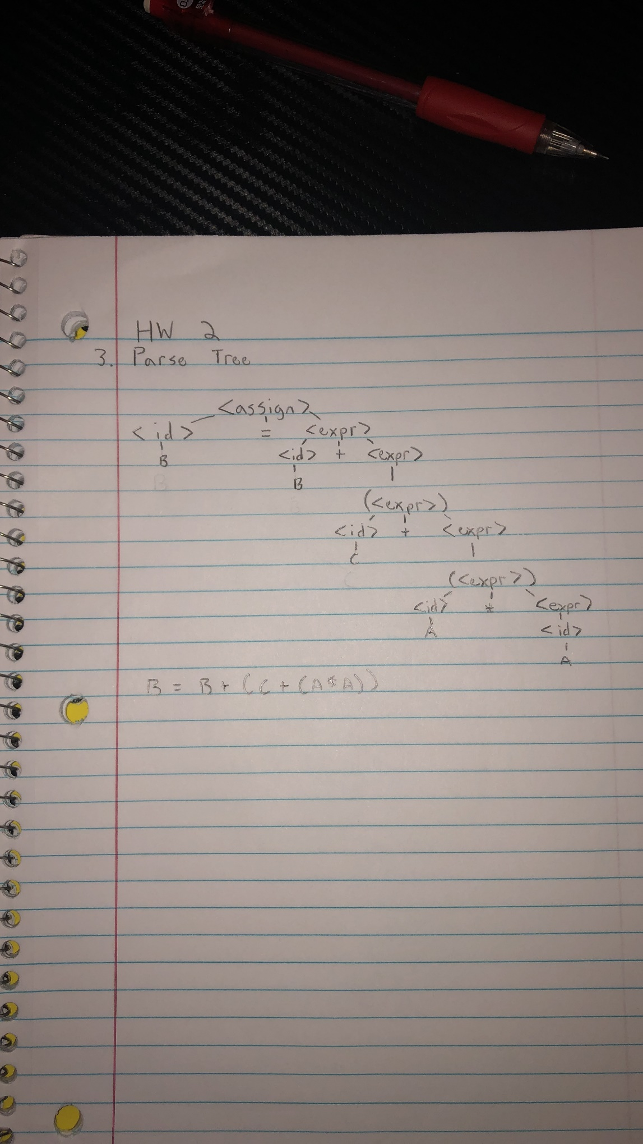

4. To remove the recursion:

A = Aa | B

A = BA’

A’ = aA’ | E

So the new grammar is:

S Aa | Bb

A CA’

A’ aA’ | bCA’ | E

B S | bb

C c

5. To resolve the pairwise disjointness:

A Aa | a

A aA’

A a

So the new grammar is:

A aA’

A’ Bc | c | E

B b | aB

6.

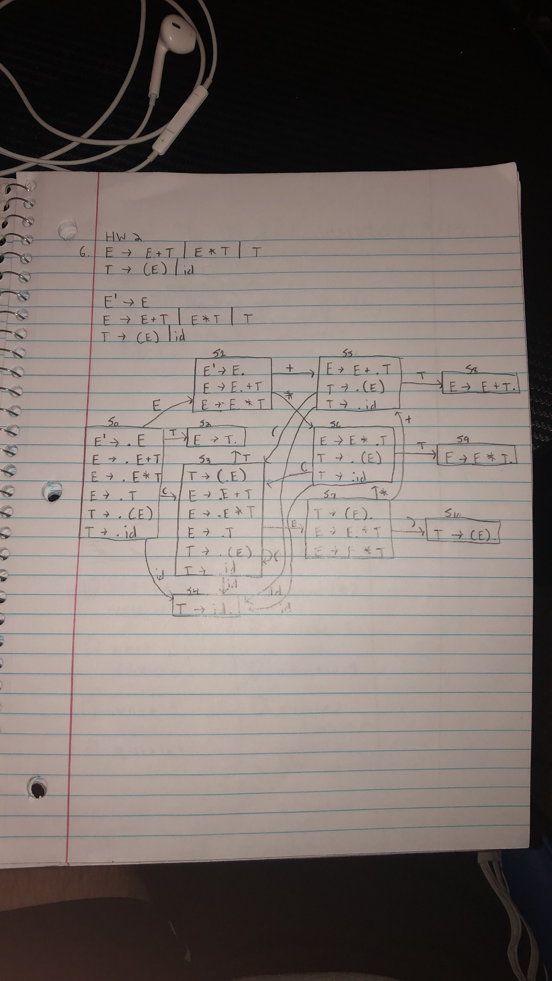

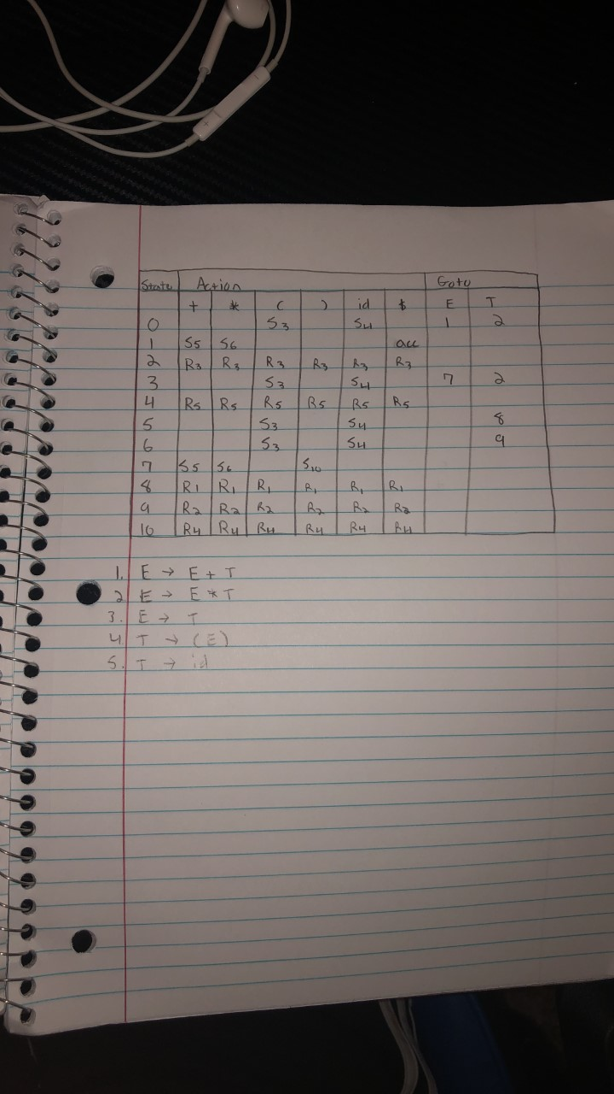

4

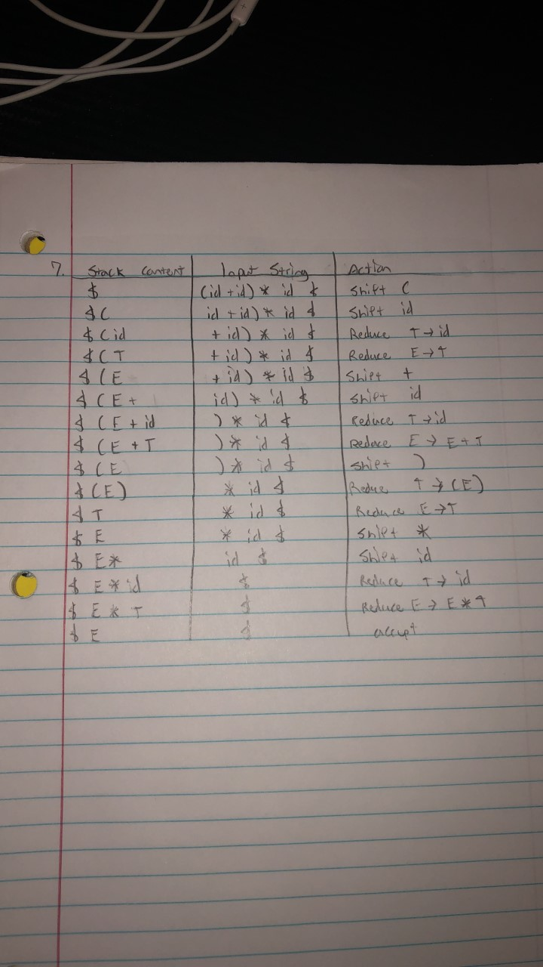7.

8.

